1. Link for this step:  
   <https://github.com/in28minutes/MockitoTutorialForBeginners/blob/master/Step13.md>
2. **Agenda**:
   1. 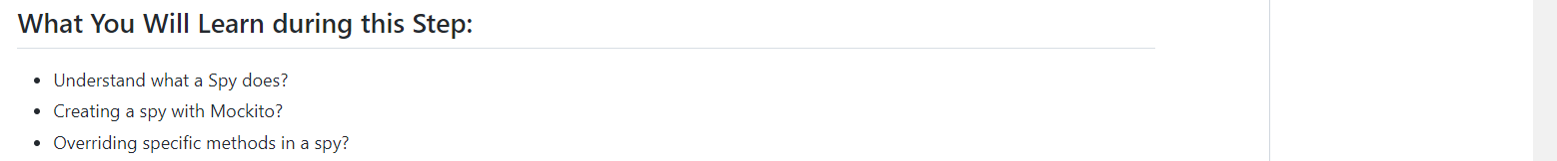
3. Stub doesn’t get business logic from the class which mocked.   
   Whereas Spy gets the business logic from the class.  
   Spy is also called Partial Mock.  
   **The test case which is about Mockito.mock() in the following snapshot**.  
   Text

   Description automatically generated  
     
   **The test case which is about Mockito.spy() in the following snapshot is getting passed**.A picture containing text

   Description automatically generated